**BIGOO COFFEE CONSOLE APPLICATION PROJECT**

**DOCUMENTATION**

**PROJECT BY**

**BUABENG EMMANUEL AIKINS**

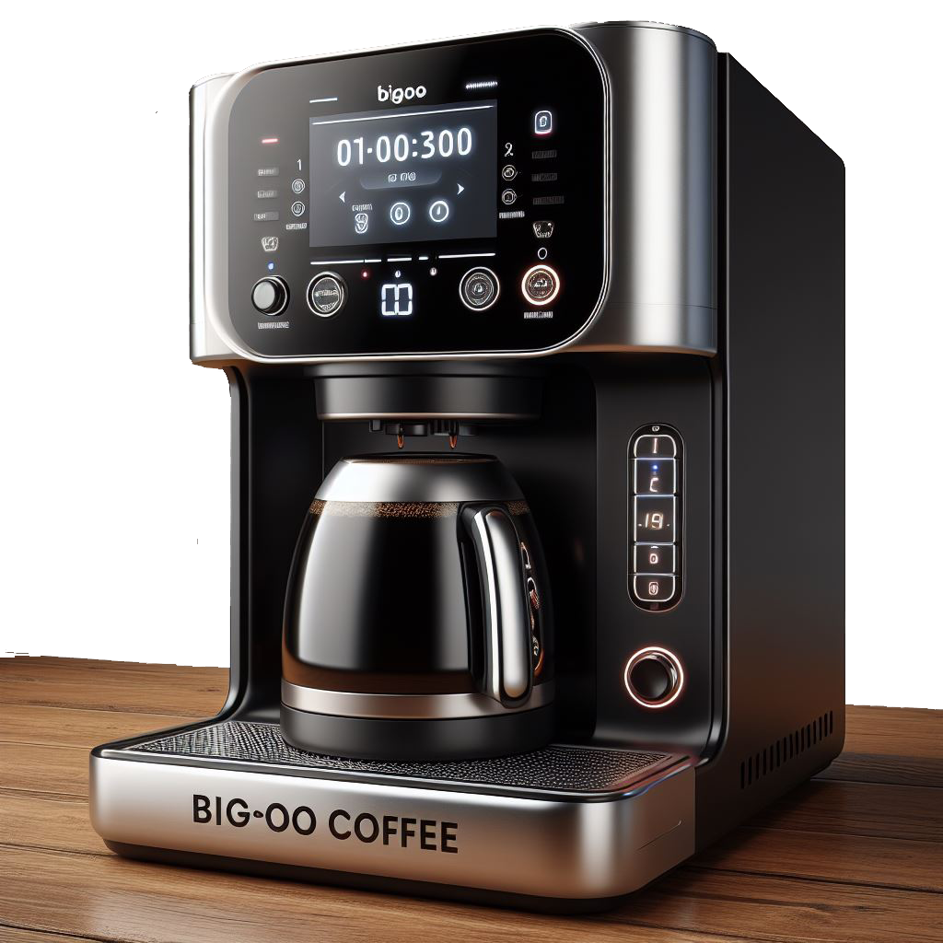

**DATE: 11TH MARCH 2024**

**OUTLINE**

1 PROBLEM BACKGROUND AND SYSTEM INTRODUCTION 3

2 FUNCTIONALITY AND DEMONSTRATION 4

2.1 PAYMENT PROCESSING 4

2.2 PRINTING RECEIPTS 5

2.3 RECORDING TRANSACTIONS 6

3.1 START UP INTERFACE: 7

3.2 DISPLAYLOADINGBAR: 9

3.3. CLEARING SCREEN: 10

4. GALLERY 11

# PROBLEM BACKGROUND AND SYSTEM INTRODUCTION

* **BACKGROUND:**

Coffee stations, whether standalone businesses or part of larger establishments, often face challenges in managing operations efficiently. Long queues, manual tracking of resources, and limited reporting capabilities can hinder the overall customer experience and business performance. The need for an automated and user-friendly solution is evident.

* **INTRODUCTION:**

Bigoo’s Coffee Machine is a command-line-based coffee station program written in C++. It offers a range of functionalities, including drink purchasing, resource tracking, reporting, and restocking. This system requires two users, Operational User and The buyer as a user

# FUNCTIONALITY AND DEMONSTRATION

# 2.1 PAYMENT PROCESSING

users can purchase drinks by inserting money. the system verifies if the inserted money is sufficient for the selected drinks and handles the payment process.

**PAYMENT PROCESSING CODE:**

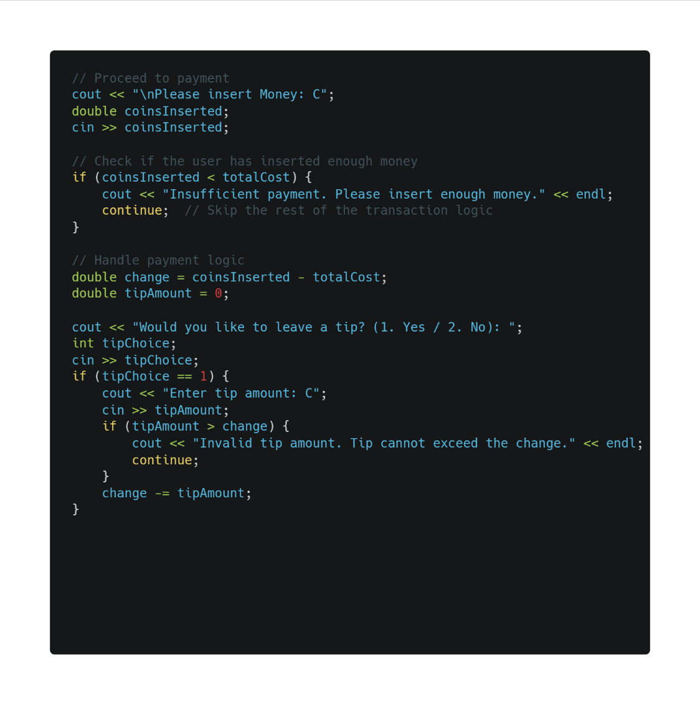

**PAYMENT OUTPUT:**

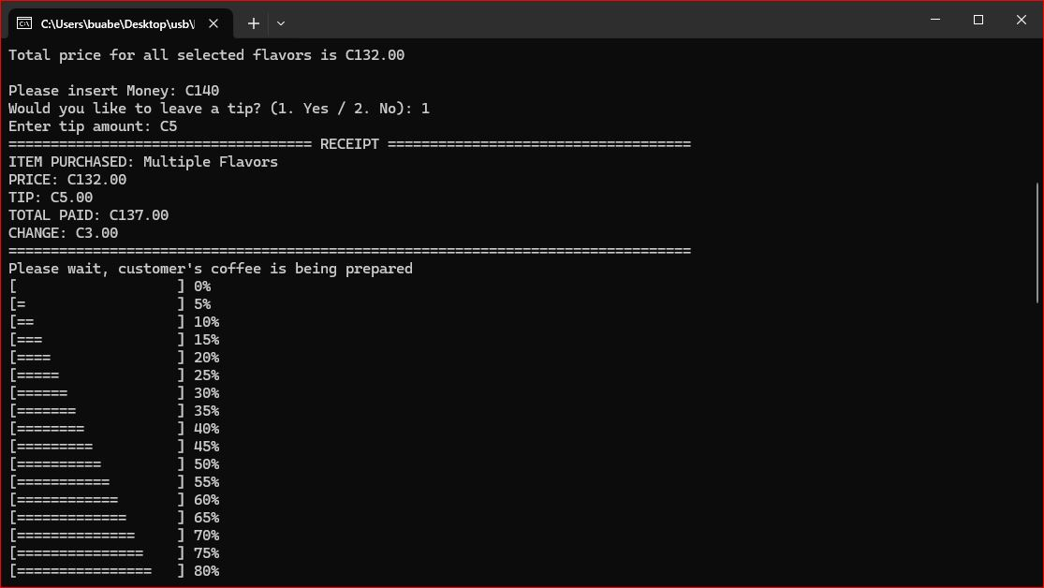

# 2.2 PRINTING RECEIPTS

Upon successful payment, receipts are generated detailing the items purchased, their prices, any tips, and the total paid.

**PRINTING RECEIPTS CODE:**

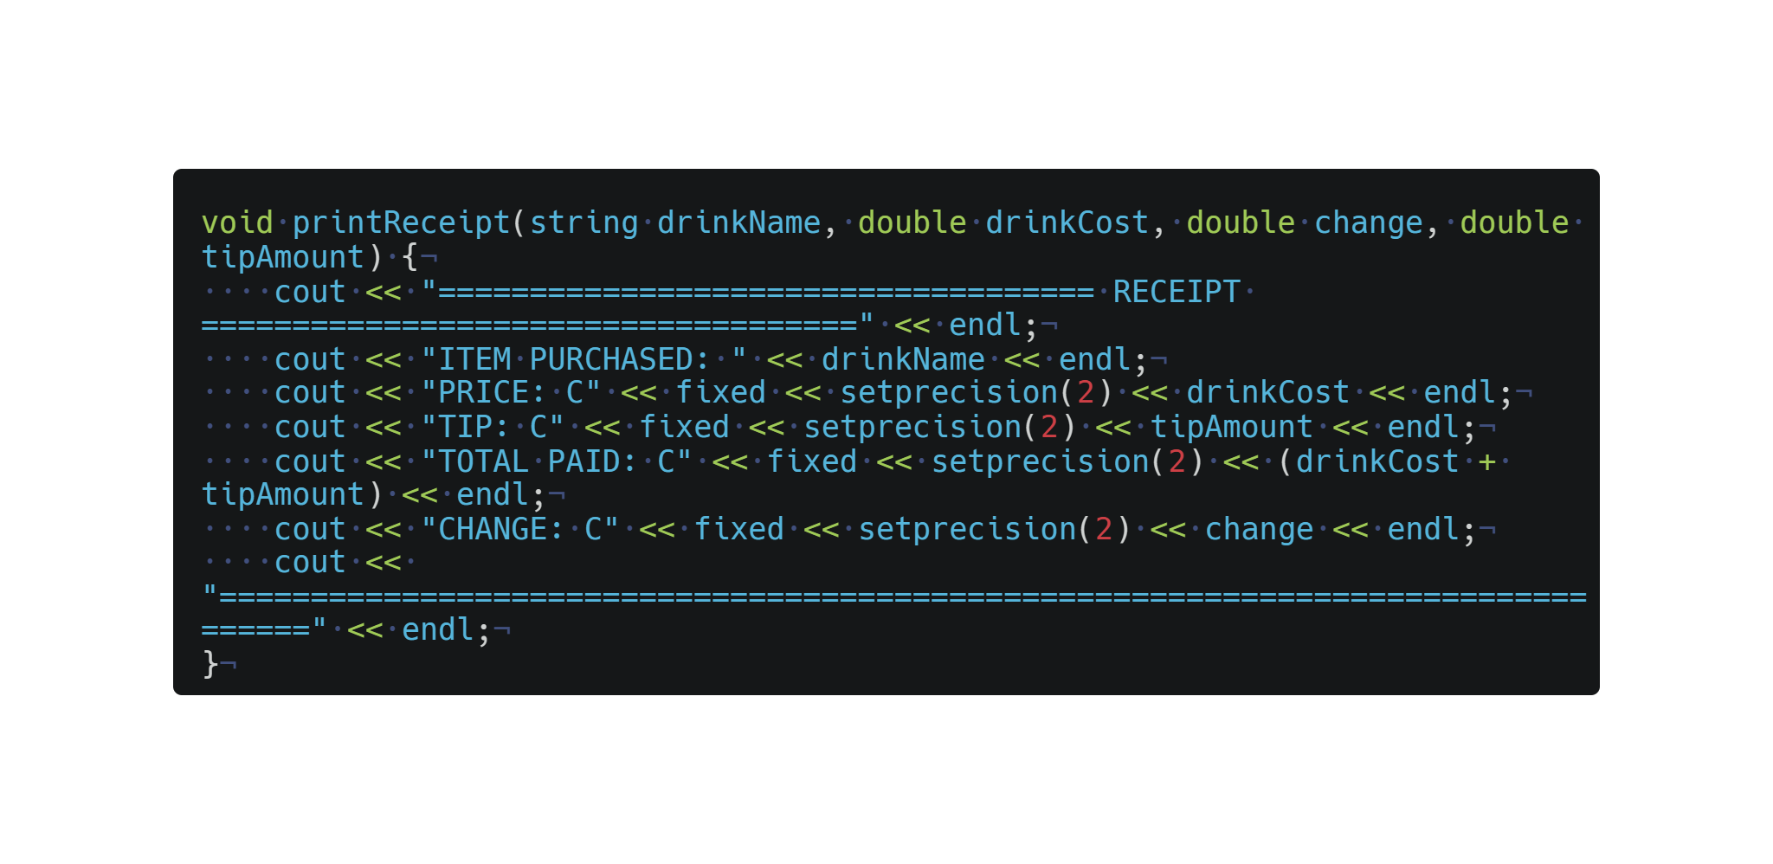

**PRINTING RECEIPTS OUTPUT:**



# 2.3 RECORDING TRANSACTIONS

All transactions, including details about the date, time, items purchased, and resource usage, are recorded in a history file

**RECORDING TRANSACTIONS CODE:**

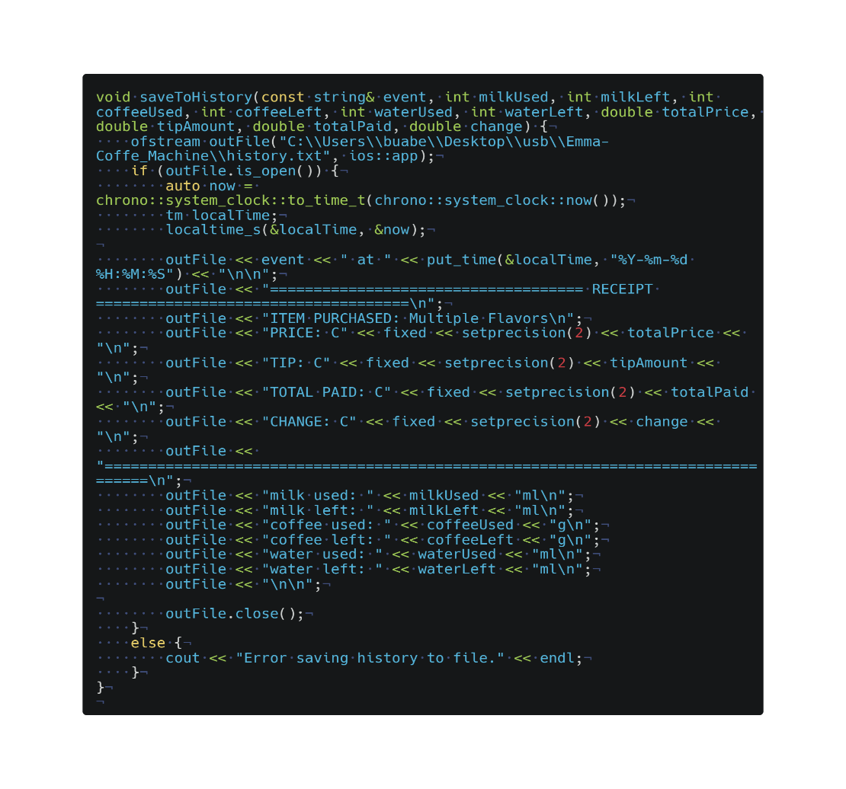

**RECORDING TRANSACTIONS OUTPUT IN EXTERNAL FILE NAMED HISTORY.TXT:**

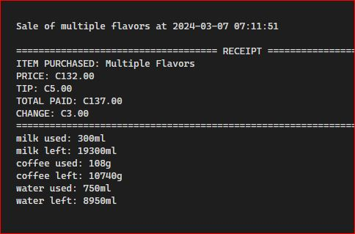

**3. USER INTERFACE**

The user interface provides clear options for users to interact with the coffee machine. It includes features like a loading bar during operations and input validation.

# 3.1 START UP INTERFACE:

This interface gives users the option to chose from being it buy a drink, check report, Restock resources and turn off machine.

The interface is categories into two.

* Administration User Interface
* Client User interface

**START UP CLIENT USER INTERFACE CODE:**

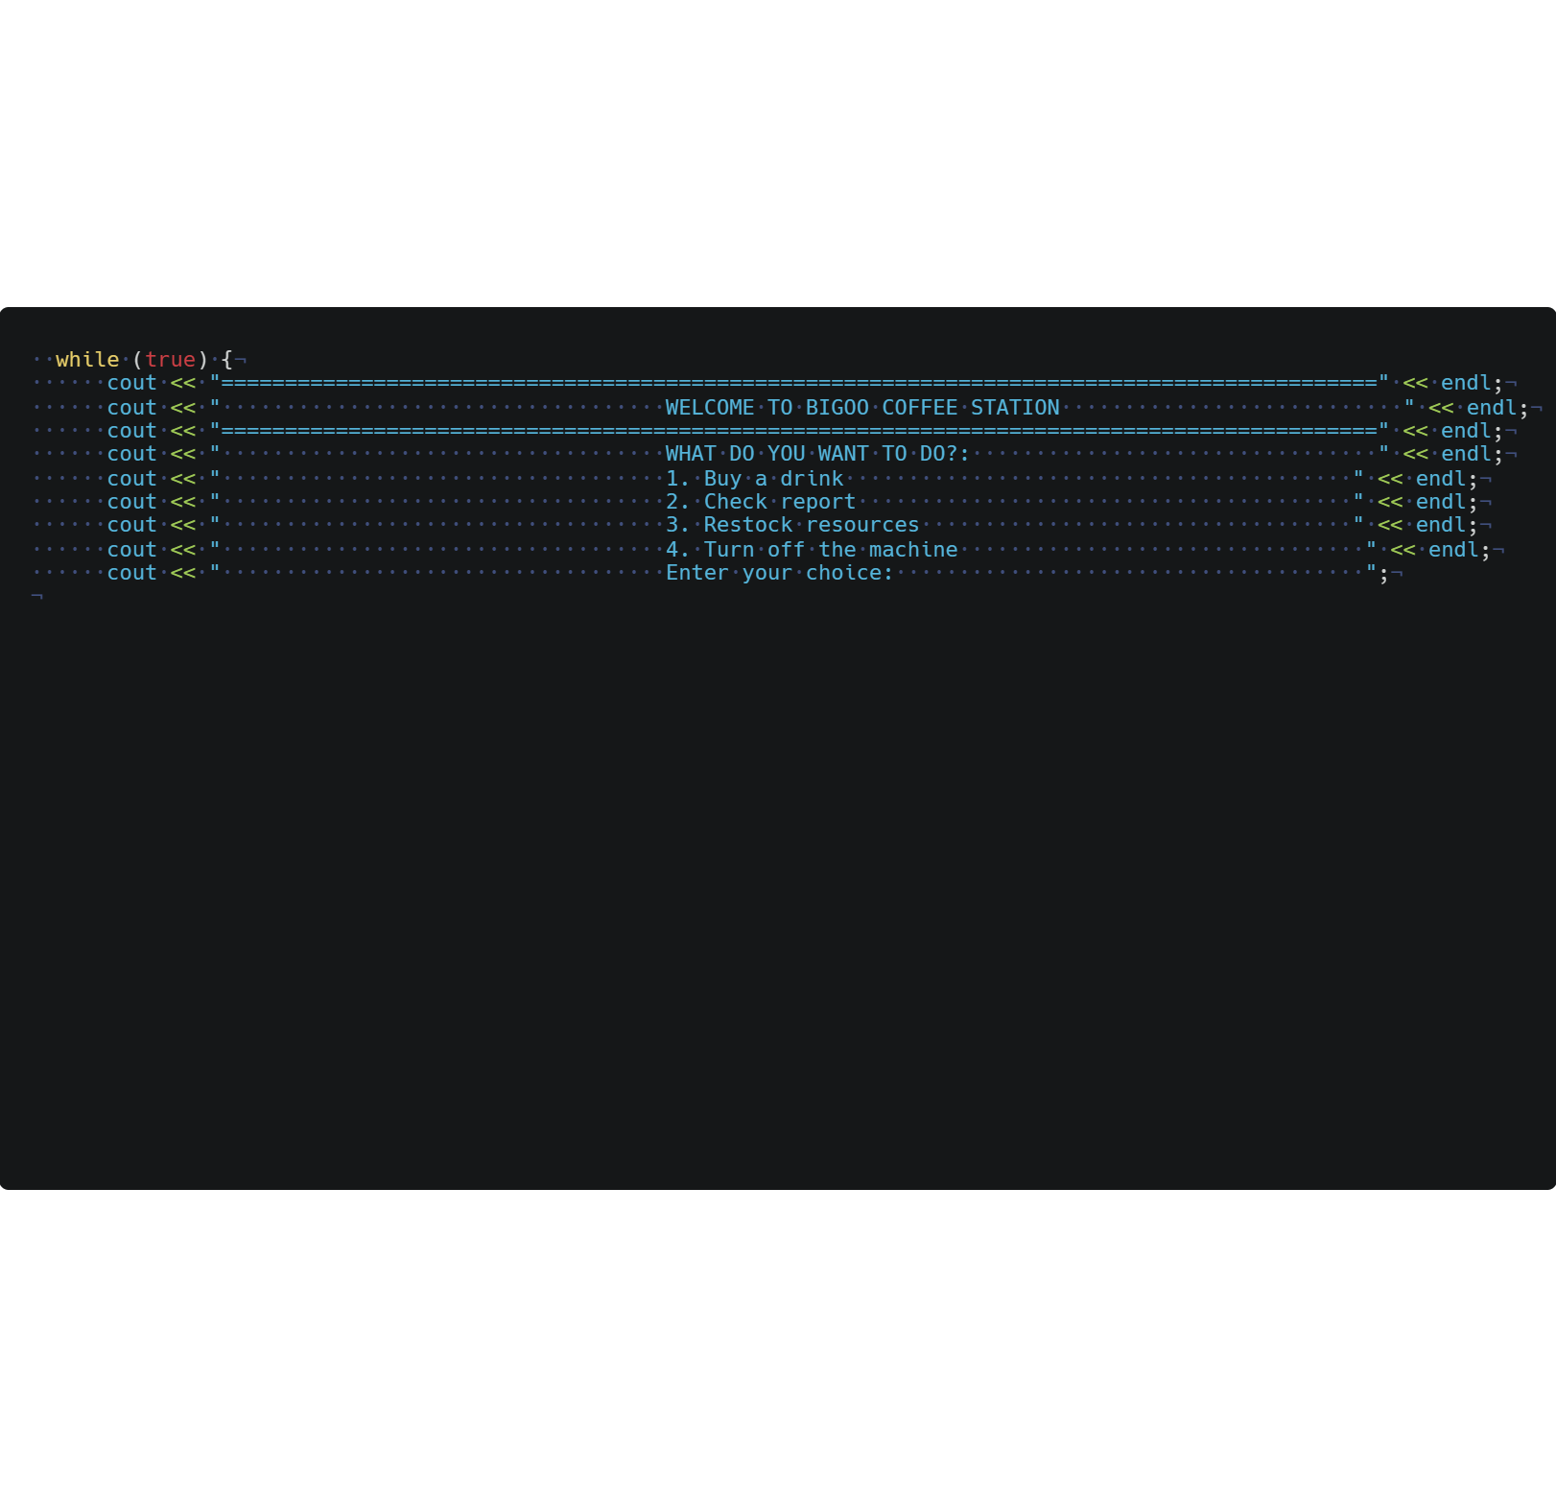

**START UP INTERFACE OUTPUT:**

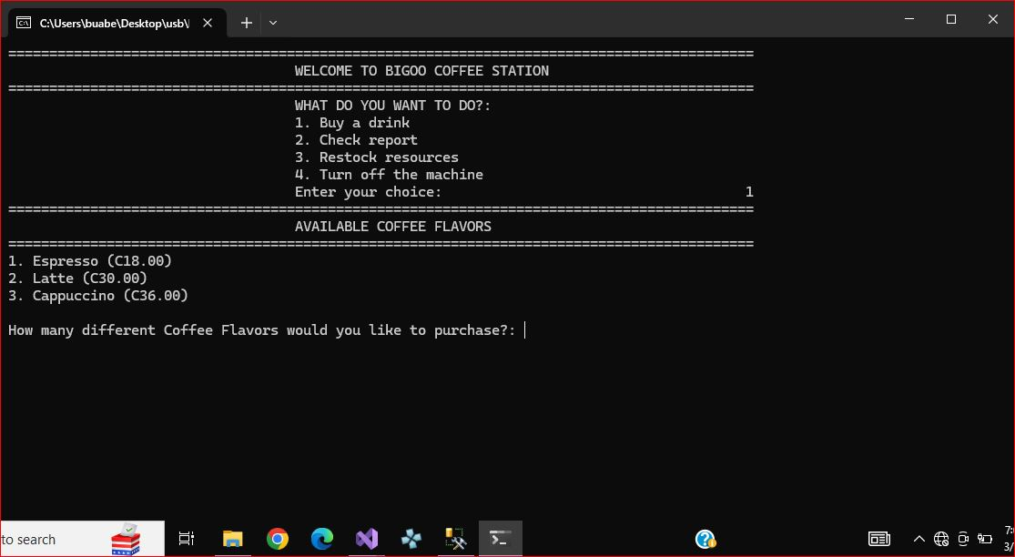

**START UP ADMINSTRATION USER INTERFACE CODE:**

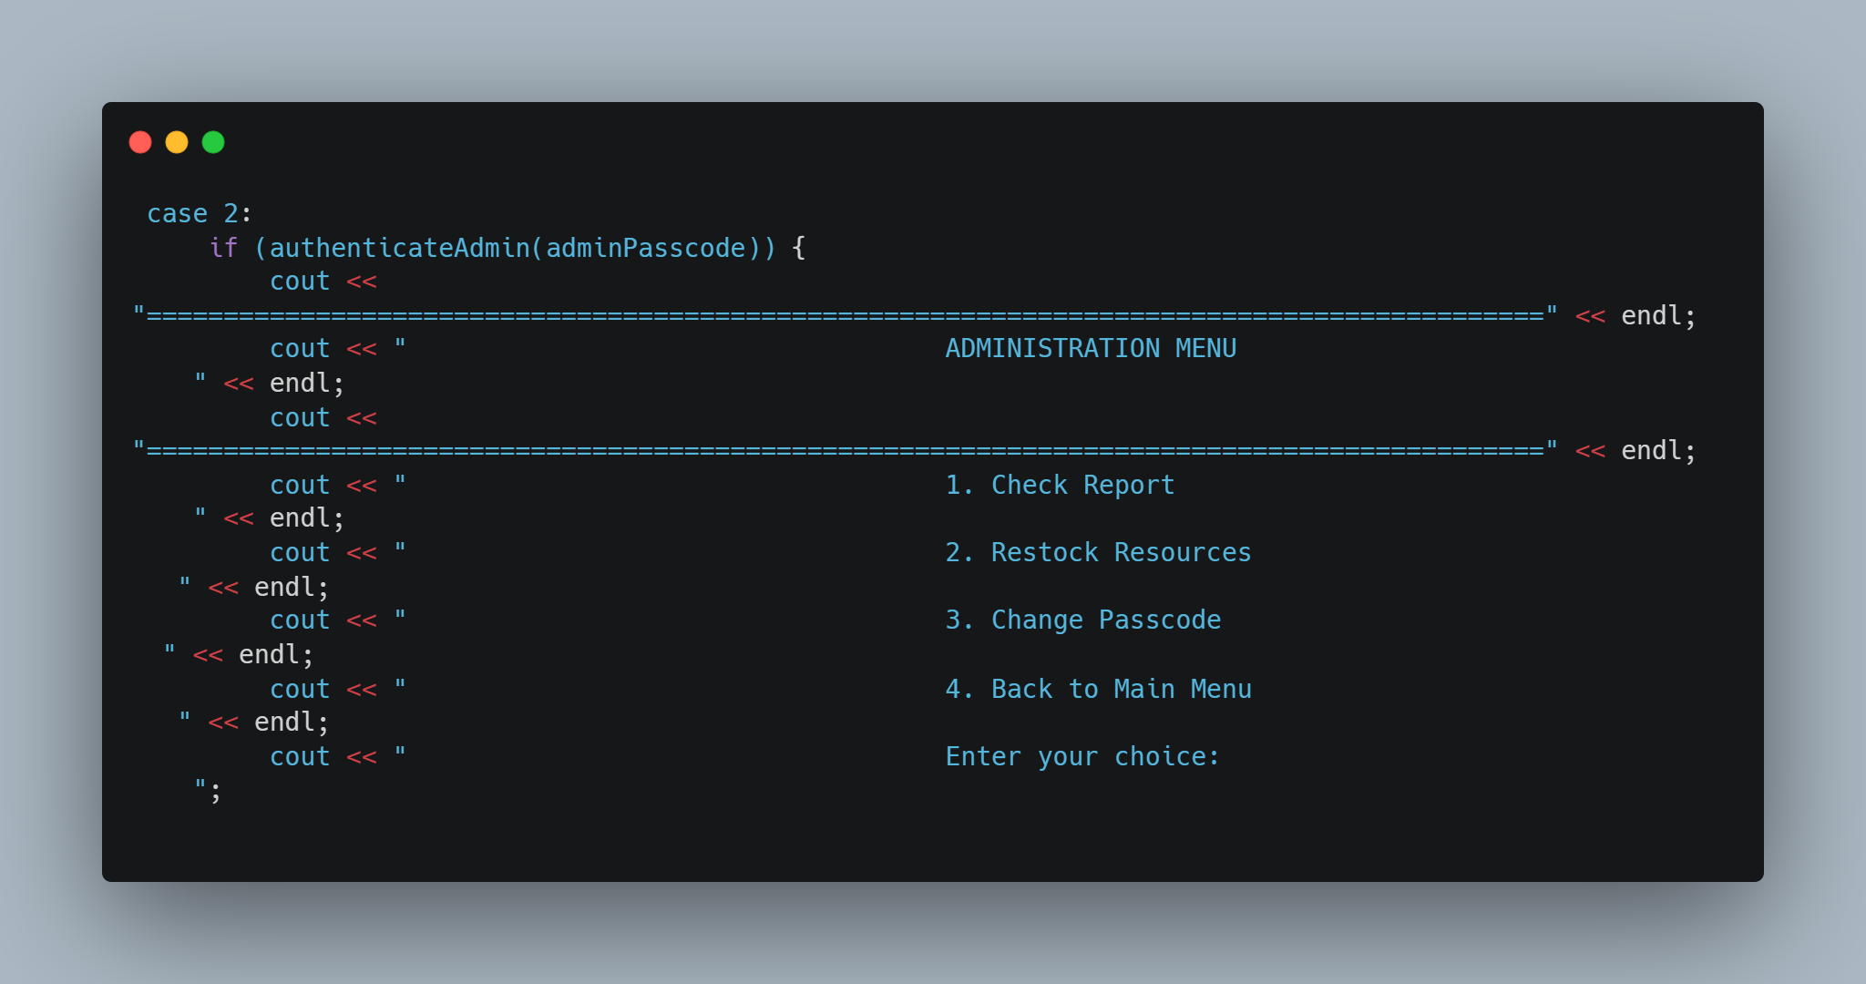

**START UP ADMINSTRATION USER INTERFACE OUTPUT:**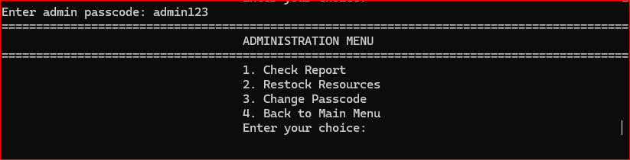

# 3.2 DISPLAYLOADINGBAR:

A loading bar is displayed during certain operations, providing visual feedback to the user about the progress of an action.

**DISPLAYLOADINGBAR CODE:**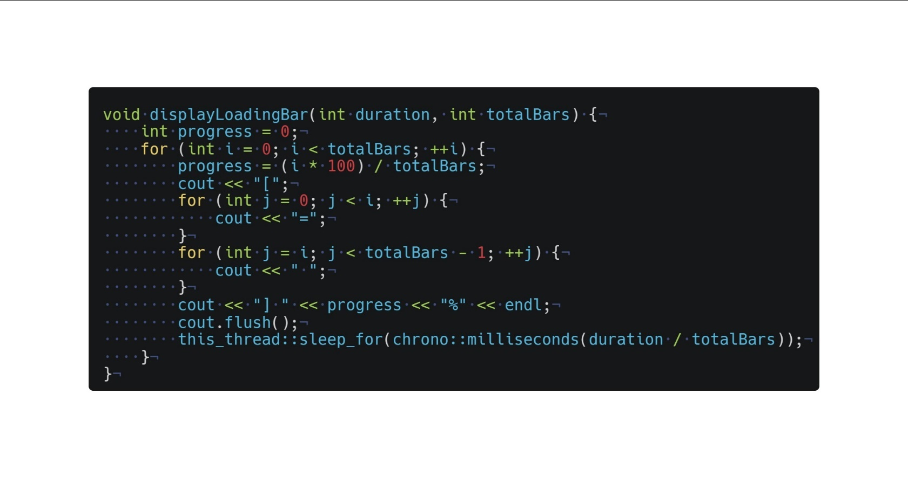

**DISPLAYLOADINGBAR OUTPUT:**



# 3.3. CLEARING SCREEN:

The screen is cleared to enhance the user interface, providing a cleaner and more readable display.

**CLEARING SCREEN CODE:**

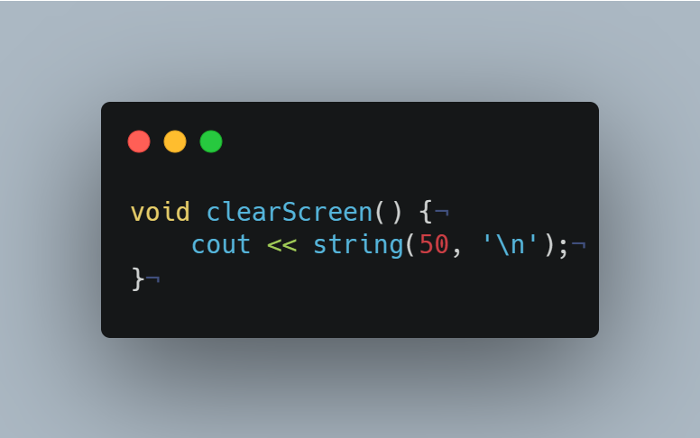

# GALLERY

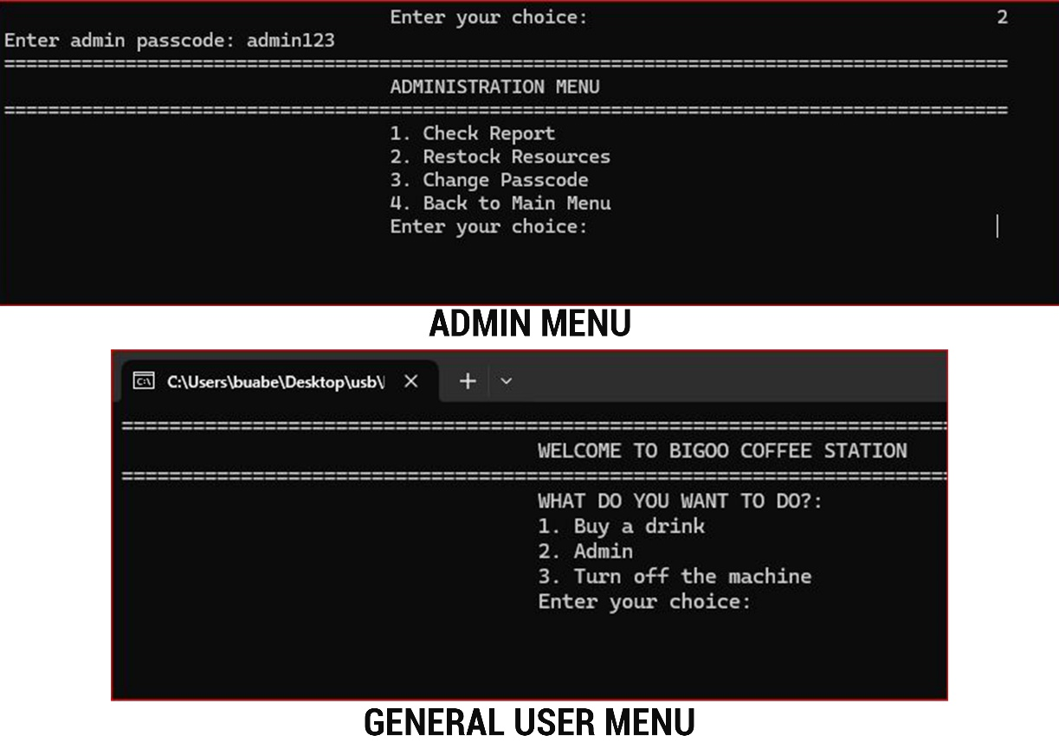

**CLIENT USER’S ACTIVITIES PROCESS**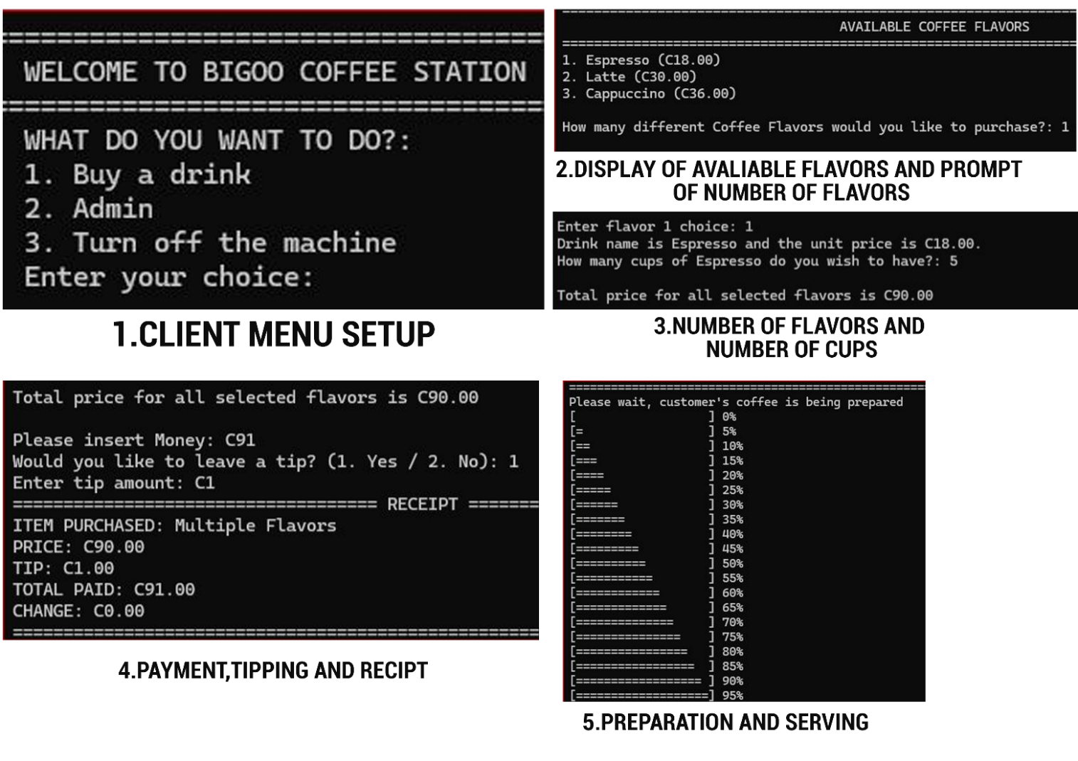

CLIENT USER’S ACTIVITIES PROCESS

**ADMINSTRATION USER’S ACTIVITIES PROCESS**

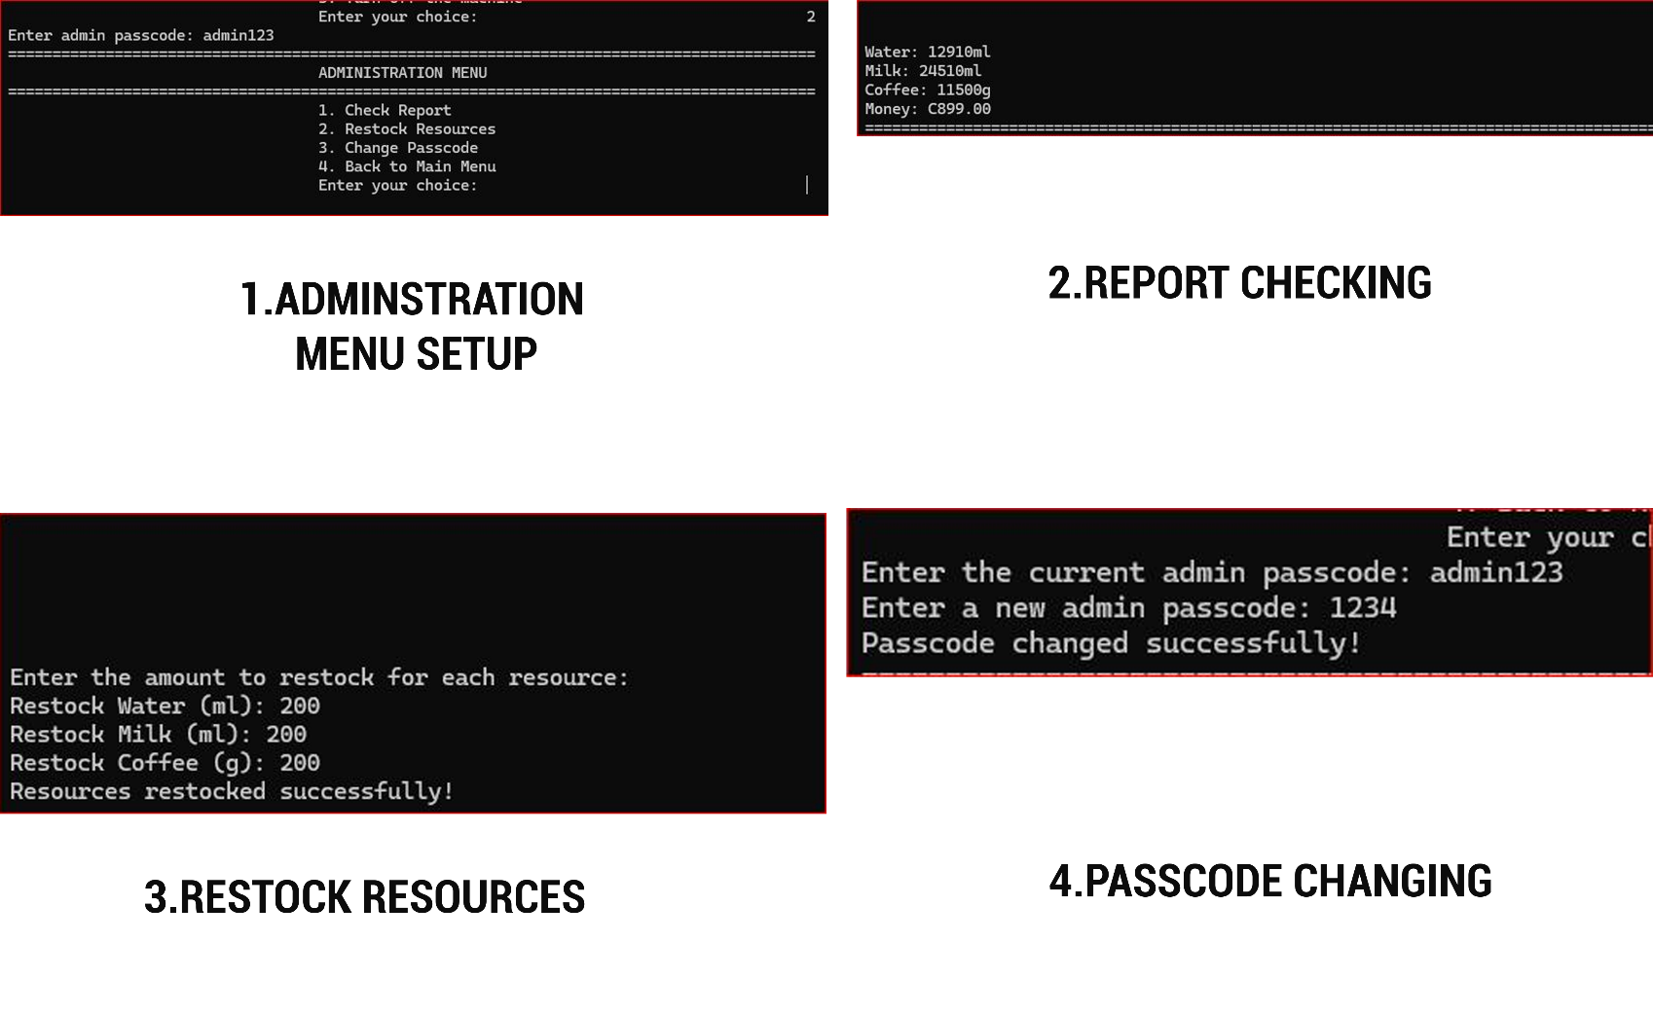

ADMINSTRATION USER’S ACTIVITIES PROCESS